PROJECT DOCUMENTATION
Magic Number–Based File Type Identifier Using Python

1. Introduction
In modern computing systems, file extensions are commonly used to identify file types. However, file extensions can be easily manipulated, leading to security threats such as malware disguised as documents or images. This project addresses this issue by identifying file types using magic numbers, which are fixed byte sequences stored in the header of files.
The proposed system reads the binary content of a file and determines its actual type by comparing its header bytes with a predefined magic number dataset. This ensures accurate, extension-independent file identification.

2. Importance of the Project
Why This Project Is Important
- Prevents file extension spoofing
- Helps in malware detection
- Useful in digital forensics
- Enhances file upload security
- Provides binary-level validation
Unlike traditional systems that trust file extensions, this project performs low-level binary analysis, making it more reliable and secure.

3. Problem Statement
File extensions do not guarantee the actual type of a file. Attackers can rename malicious executables as harmless document files, bypassing basic security checks. There is a need for a system that identifies file types based on their actual binary structure rather than their names.

4. Objectives
- To identify file types using magic numbers
- To detect file extension spoofing
- To generate forensic-grade logs
- To calculate cryptographic hashes for file integrity
- To provide a command-line interface for scanning files

5. Project Scope
- Works on any operating system
- Supports multiple file formats
- Can be extended for malware detection
- Can be integrated into email gateways or upload filters

6. System Architecture
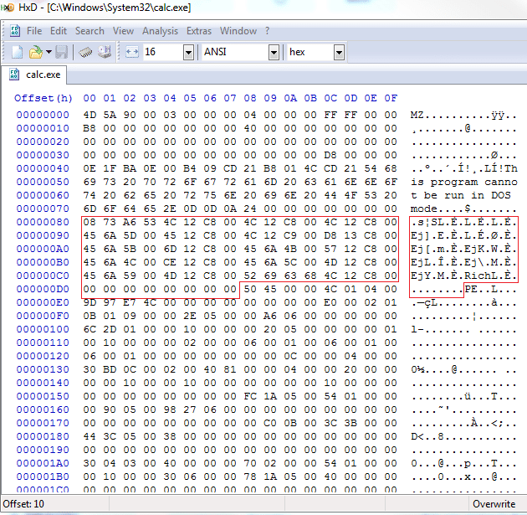
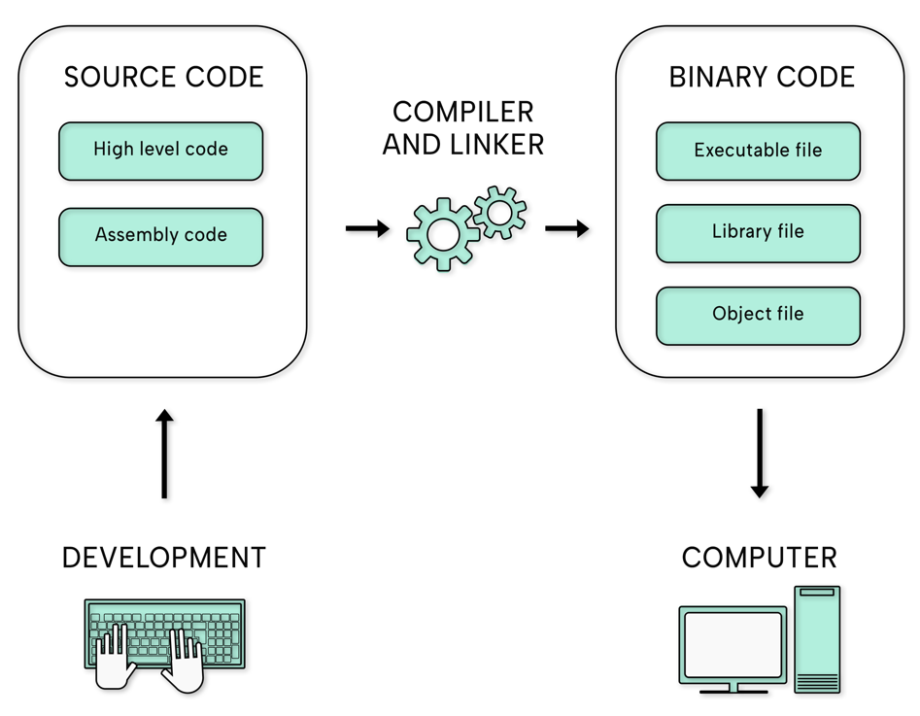

Architecture Flow:
- File input
- Binary header extraction
- Signature comparison
- Extension validation
- Risk assessment
- Forensic logging
- Report generation

7. Dataset Description (magic_signatures.json)
The dataset contains known file signatures (magic numbers) along with their corresponding file types.

Dataset Fields:
Field | Description
type | Actual file type
extension | Expected file extension
magic_hex | Magic number in hexadecimal
offset | Byte offset of signature
Dataset Source:
- Wikipedia file signature list
- Digital forensics references
- Unix libmagic database

8. Technologies Used
Technology | Purpose
Python | Core implementation
JSON | Magic number dataset & logs
Hashlib | SHA-256 hashing
OS module | File path & extension handling
Datetime | Timestamp generation

9. Functional Modules & Important Functions
9.1 Binary Reader Module
Function: read_magic_bytes()
Purpose:
Reads the first few bytes of a file in binary mode and converts them into hexadecimal format.
Why Used:
Magic numbers are stored at the beginning of a file, so reading only a small portion improves efficiency.
Function Used:
open(file, "rb")

9.2 Signature Loading Module
Function: load_signatures()
Purpose:
Loads magic number data from magic_signatures.json.
Why Used:
Separates data from logic, making the system modular and extensible.
Function Used:
json.load()

9.3 Signature Matching Engine
Function: match_signature()
Purpose:
Compares extracted file header bytes with known magic numbers.
Why Used:
Determines the actual file type using deterministic matching.
Matching Method:
Offset-based hex comparison.

9.4 Extension Analysis Module
Function: analyze_extension()
Purpose:
Compares detected file type with file extension.
Why Used:
Detects file extension spoofing and assigns risk levels.
Risk Levels:
- LOW
- HIGH
- CRITICAL

9.5 Cryptographic Hashing Module
Function: calculate_sha256()
Purpose:
Generates SHA-256 hash of the file.
Why Used:
Ensures file integrity and supports forensic analysis.
Algorithm Used:
SHA-256 (Secure Hash Algorithm)

9.6 Forensic Logging Module
Function: log_forensic_event()
Purpose:
Stores analysis results in a structured log file.
Why Used:
Provides audit trails and non-repudiation.
Log Format:
JSON

9.7 Reporting Module
Function: display_report()
Purpose:
Displays scan results in a readable format.
Why Used:
Improves usability and demonstration clarity.

9.8 Main Detection Engine
Function: detect_file()
Purpose:
Integrates all modules and performs full file analysis.
Why Used:
Acts as the control unit of the system.

10. Program Flow
- User inputs file path
- Binary header is read
- Magic number comparison is performed
- File extension is analyzed
- SHA-256 hash is generated
- Risk is evaluated
- Forensic log is updated
- Report is displayed

11. Advantages
- Accurate file identification
- Prevents spoofing attacks
- Lightweight and fast
- Platform-independent
- Forensic-grade logging

12. Limitations
- Cannot detect encrypted containers
- Limited to known signatures
- No deep content analysis

13. Future Enhancements
- Recursive archive scanning
- Email attachment scanning
- Integration with SIEM systems
- Kernel-level file monitoring
- Web-based interface

14. Conclusion
This project demonstrates a reliable and secure method of identifying file types using magic numbers. By analyzing binary headers instead of relying on file extensions, the system effectively mitigates spoofing attacks and provides accurate forensic evidence. The modular design allows easy extension and real-world integration.

15. Conclusion
